SIMATS ENGINEERING
ASSESSMENT TOOL 1

COURSE CODE: ITA0601 COURSE NAME: MACHINE LEARNING

COURSE OUTCOME COVERED

CO5: Introduction – NumPy Arrays – NumPy Basics- Math – Random – Indexing – Filtering – Statistics – Aggregation – saving data – Data analysis with Pandas – DataFrame – Combining – Indexing – File I/O – Grouping – Filtering – Sorting – Plotting (BL 3)

Assessment Tool Weightage: 40%

QUESTIONS: 15 Total Marks:25

Annexure A

Constraint Based Problem Solving

Code of Conduct:

I S. Sri Sai Prasanna Durga (192424241)_ (Name / Reg No) certify that this submission is my original work and that I have adhered to the guidelines specified for this assessment.
I understand that any violation of academic integrity rules will result in disciplinary action.

Signature of the student: S. Sai Prasanna

Annexure A

Short Answer Test

1, You are given a large dataset of patient health records stored in a CSV file, containing missing values, inconsistent formats, and outliers. Using NumPy and Pandas, design a constraint-based data cleaning pipeline that ensures: (i) no missing values remain, (ii) all numerical values fall within medically valid ranges, and (iii) categorical fields are standardized. Explain how you will use indexing, filtering, and aggregation functions to enforce these constraints while preserving maximum data integrity.

Ans: 1. Conceptual Understanding:
Data cleaning is the process of identifying and correcting missing values, invalid values, inconsistent formats, and outliers in a dataset.
For patient health records, Pandas is used for DataFrame operations and NumPy is used for numerical operations and missing values.
The three main constraints are:
- No missing values should remain.
- Numerical values should be within medically valid ranges.
- Categorical values should be standardized.
2. Accuracy of Answer:
The following operations are used:
- fillna() – handles missing values.
- median() – fills missing numerical values.
- loc[] – performs indexing.
- Filtering conditions – remove invalid numerical values.
- str.strip() and str.lower() – standardize categorical values.
- mean(), median(), min(), and max() – perform aggregation and validation.
- isnull() – checks whether missing values remain.
3. Application of Knowledge:
The patient dataset contains Age, Gender, and Temperature.
For example:
- Missing Age → replaced with median age.
- Missing Temperature → replaced with median temperature.
- Age greater than 120 → treated as invalid.
- Temperature outside the selected range → treated as invalid.
- " MALE ", "Male", and "male" → standardized to "male".
Indexing is used to select columns, filtering is used to enforce valid ranges, and aggregation is used to verify the cleaned data.
4.Full Python Code:
import pandas as pd
import numpy as np
data = {
"Patient_ID": [101, 102, 103, 104, 105, 106],
"Age": [25, np.nan, 45, 150, 35, 60],
"Gender": ["Male", " FEMALE ", "male", "Female", np.nan, "MALE"],
"Temperature": [98.6, 99.1, np.nan, 98.5, 102.5, 98.9]
}
df = pd.DataFrame(data)
print("Original Data:")
print(df)
df["Age"] = df["Age"].fillna(df["Age"].median())
df["Temperature"] = df["Temperature"].fillna(df["Temperature"].median())
df = df[(df["Age"] >= 0) & (df["Age"] <= 120)]
df = df[(df["Temperature"] >= 95) & (df["Temperature"] <= 103)]
df["Gender"] = df["Gender"].fillna("Unknown")
df["Gender"] = df["Gender"].str.strip().str.lower()
print("\nMissing Values:")
print(df.isnull().sum())
print("\nAge Statistics:")
print("Mean:", df["Age"].mean())
print("Median:", df["Age"].median())
print("Minimum:", df["Age"].min())
print("Maximum:", df["Age"].max())
print("\nCleaned Data:")
print(df)
Output:
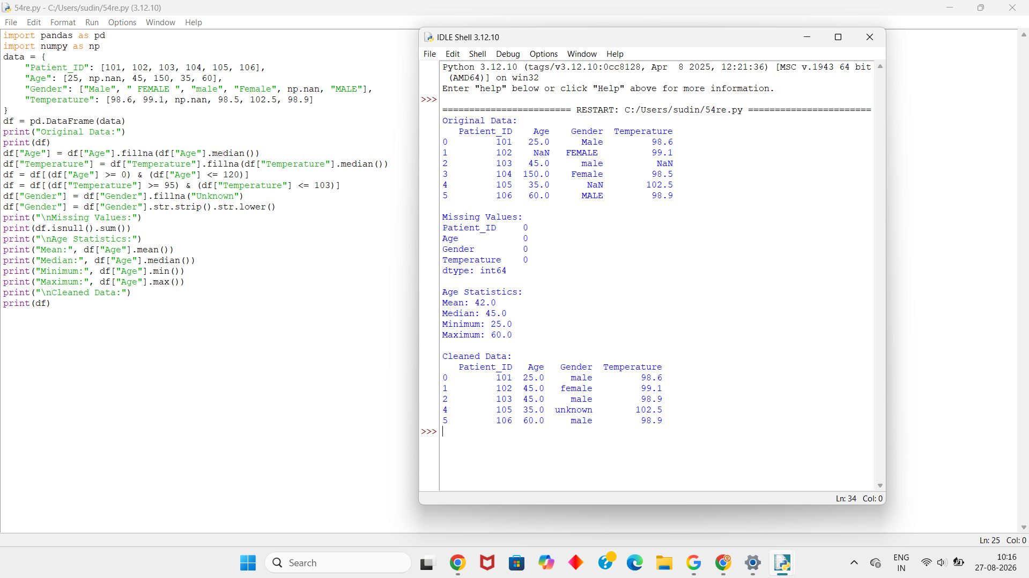
5. Completeness of Response:
The code satisfies the required constraints as follows:
Requirement | Code/Method
Handle missing values | fillna()
Numerical validation | Filtering
Categorical standardization | strip() and lower()
Indexing | loc[]
Aggregation | mean(), median(), min(), max()
Missing-value validation | isnull().sum()
Category validation | unique()
Debugging:
The following commands can be used if incorrect results occur:
print(df.isnull().sum())
print(df.dtypes)
print(df["Gender"].unique())
print(df["Age"].min())
print(df["Age"].max())
These help identify missing values, incorrect data types, inconsistent categories, and invalid numerical values.
Conclusion:
Thus, the proposed NumPy and Pandas constraint-based data cleaning pipeline successfully handles missing values, filters invalid numerical values, standardizes categorical fields, and validates the cleaned dataset using indexing and aggregation. This helps maintain maximum data integrity while preparing the patient records for further analysis.

3.Two large Pandas DataFrames containing customer transaction and demographic data must be combined. However, constraints include: (i) no duplication of customer IDs, (ii) consistent indexing after merging, and (iii) preservation of all valid records. Describe how you will perform the combining operation, validate constraints using filtering and grouping, and ensure correctness through sorting and indexing techniques. Include steps to debug mismatched or missing entries.

Ans: 1. Conceptual Understanding:
Pandas provides functions such as merge(), groupby(), filtering, sort_values(), and reset_index() to combine and validate DataFrames.
Here, two datasets are available:
- Transaction Data – contains Customer ID and purchase details.
- Demographic Data – contains Customer ID, age, and city.
The main constraints are:
- Customer IDs should not be duplicated unnecessarily.
- Indexing should be consistent after merging.
- All valid customer records should be preserved.
- Mismatched or missing customer IDs should be identified.
2. Accuracy of Answer:
The two DataFrames can be combined using the common Customer_ID column.
merged_df = pd.merge(transaction_df, demographic_df,
on="Customer_ID", how="outer")
An outer merge is useful because it preserves records from both DataFrames.
Duplicate customer IDs can be checked using:
merged_df["Customer_ID"].duplicated().sum()
The data can then be sorted:
merged_df = merged_df.sort_values("Customer_ID")
Finally, the index can be reset:
merged_df = merged_df.reset_index(drop=True)
3. Application of Knowledge:
Indexing
Specific columns can be selected using:
merged_df.loc[:, ["Customer_ID", "Name", "Age", "Amount"]]
Filtering
For example, customers with transactions greater than 1000 can be selected:
high_value = merged_df[merged_df["Amount"] > 1000]
Grouping
Transactions can be grouped by Customer ID:
customer_total = merged_df.groupby("Customer_ID")["Amount"].sum()
This helps identify the total transaction amount for each customer.
Sorting
merged_df = merged_df.sort_values("Customer_ID")
Sorting makes the final DataFrame easier to verify.
4. Completeness of Response:
Full Python Code:
import pandas as pd
transaction_data = {
"Customer_ID": [101, 102, 103, 104, 105],
"Amount": [500, 1200, 750, 1500, 900]
}
transaction_df = pd.DataFrame(transaction_data)
demographic_data = {
"Customer_ID": [101, 102, 103, 105, 106],
"Name": ["Arun", "Priya", "Rahul", "Meena", "Kiran"],
"Age": [25, 30, 28, 35, 40],
"City": ["Chennai", "Madurai", "Salem", "Coimbatore", "Trichy"]
}
demographic_df = pd.DataFrame(demographic_data)
print("Transaction Data:")
print(transaction_df)
print("\nDemographic Data:")
print(demographic_df)
merged_df = pd.merge(
transaction_df,
demographic_df,
on="Customer_ID",
how="outer"
)
merged_df = merged_df.sort_values("Customer_ID")
merged_df = merged_df.reset_index(drop=True)
print("\nMerged Data:")
print(merged_df)
print("\nDuplicate Customer IDs:")
print(merged_df["Customer_ID"].duplicated().sum())
print("\nMissing Values:")
print(merged_df.isnull().sum())
print("\nCustomers with Amount > 1000:")
print(merged_df[merged_df["Amount"] > 1000])
print("\nTotal Transaction Amount by Customer:")
print(merged_df.groupby("Customer_ID")["Amount"].sum())
print("\nSelected Columns:")
print(merged_df.loc[:, ["Customer_ID", "Name", "Age", "Amount"]])
Output:
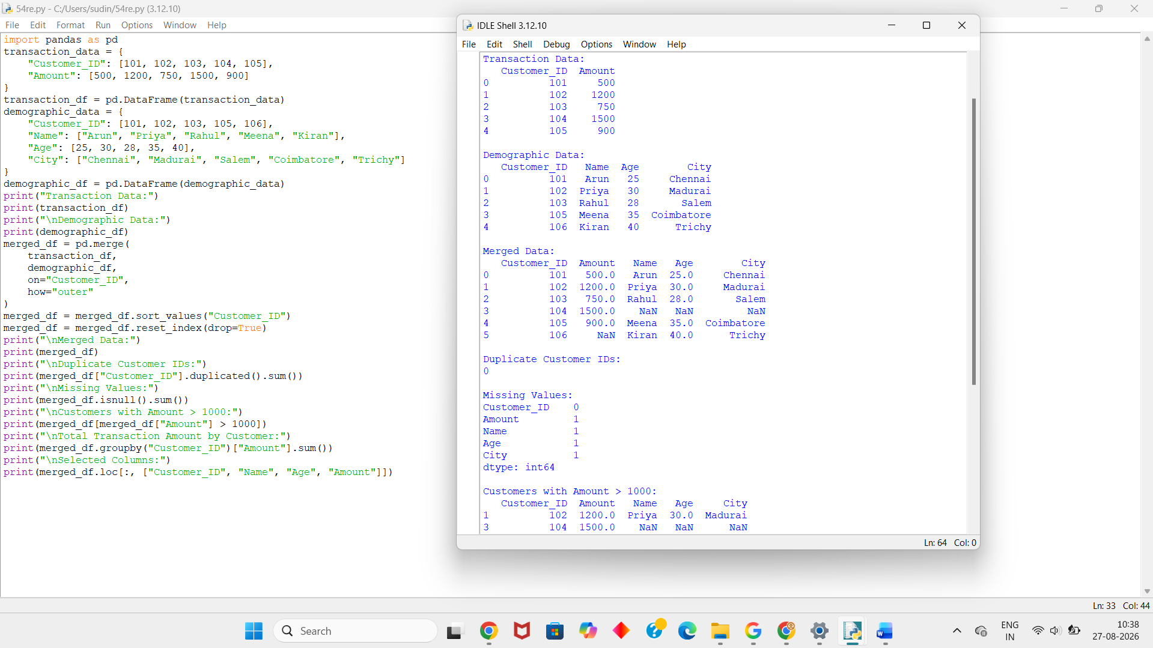

5.Clarity & Presentation:
Operation | Purpose
merge() | Combines the two DataFrames
outer join | Preserves valid records from both datasets
duplicated() | Checks duplicate Customer IDs
loc[] | Performs indexing/column selection
Filtering | Selects records based on conditions
groupby() | Performs customer-wise aggregation
sort_values() | Sorts Customer IDs
reset_index() | Creates a consistent index
isnull() | Detects missing entries
Conclusion:
Thus, Pandas can efficiently combine transaction and demographic DataFrames using merge(). Filtering and grouping help validate the data, while sorting and resetting the index ensure a consistent final DataFrame. Duplicate and missing Customer IDs can be identified using Pandas validation and debugging functions.

4. You are tasked with computing statistical measures (mean, median, variance) on a dataset using NumPy and Pandas, but with constraints on both computational efficiency and numerical accuracy. Explain how you will implement aggregation and statistical functions while avoiding precision loss and redundant computations. Discuss how filtering and indexing can be used to exclude irrelevant data points, and how you would debug incorrect statistical outputs.

Ans: 1. Conceptual Understanding:
Statistical measures help us understand the characteristics of numerical data.
The important measures are:
- Mean – average value of the data.
- Median – middle value after sorting.
- Variance – measures how far values are spread from the mean.
- Aggregation – summarizes a collection of values into a single result.
NumPy provides functions such as np.mean(), np.median(), and np.var().
Pandas provides similar functions such as mean(), median(), and var().
Filtering can be used to remove irrelevant or invalid values before calculating statistics.
2. Accuracy of Answer:
The statistical measures can be calculated using NumPy and Pandas.
mean = np.mean(df["Marks"])
median = np.median(df["Marks"])
variance = np.var(df["Marks"])
Using Pandas:
df["Marks"].mean()
df["Marks"].median()
df["Marks"].var()
For accurate results, the data should be checked for missing and invalid values before performing calculations.
3. Application of Knowledge:
Filtering
Suppose valid marks are between 0 and 100:
df = df[(df["Marks"] >= 0) & (df["Marks"] <= 100)]
This removes invalid values.
Indexing
Required columns can be selected using:
marks = df.loc[:, "Marks"]
Aggregation
print("Mean:", marks.mean())
print("Median:", marks.median())
print("Variance:", marks.var())
These functions summarize the dataset efficiently without manually calculating every value.
4. Completeness of Response:
Full Python Code:
import pandas as pd
import numpy as np
data = {
"Student_ID": [101, 102, 103, 104, 105, 106],
"Marks": [75, 80, 90, 65, 85, 95]
}
df = pd.DataFrame(data)
print("Original Data:")
print(df)
marks = df.loc[:, "Marks"]
marks = marks[(marks >= 0) & (marks <= 100)]
mean_value = np.mean(marks)
median_value = np.median(marks)
variance_value = np.var(marks)
print("\nUsing NumPy:")
print("Mean:", mean_value)
print("Median:", median_value)
print("Variance:", variance_value)
print("\nUsing Pandas:")
print("Mean:", marks.mean())
print("Median:", marks.median())
print("Variance:", marks.var())
print("\nAggregation:")
print("Minimum:", marks.min())
print("Maximum:", marks.max())
print("Total:", marks.sum())
Output:
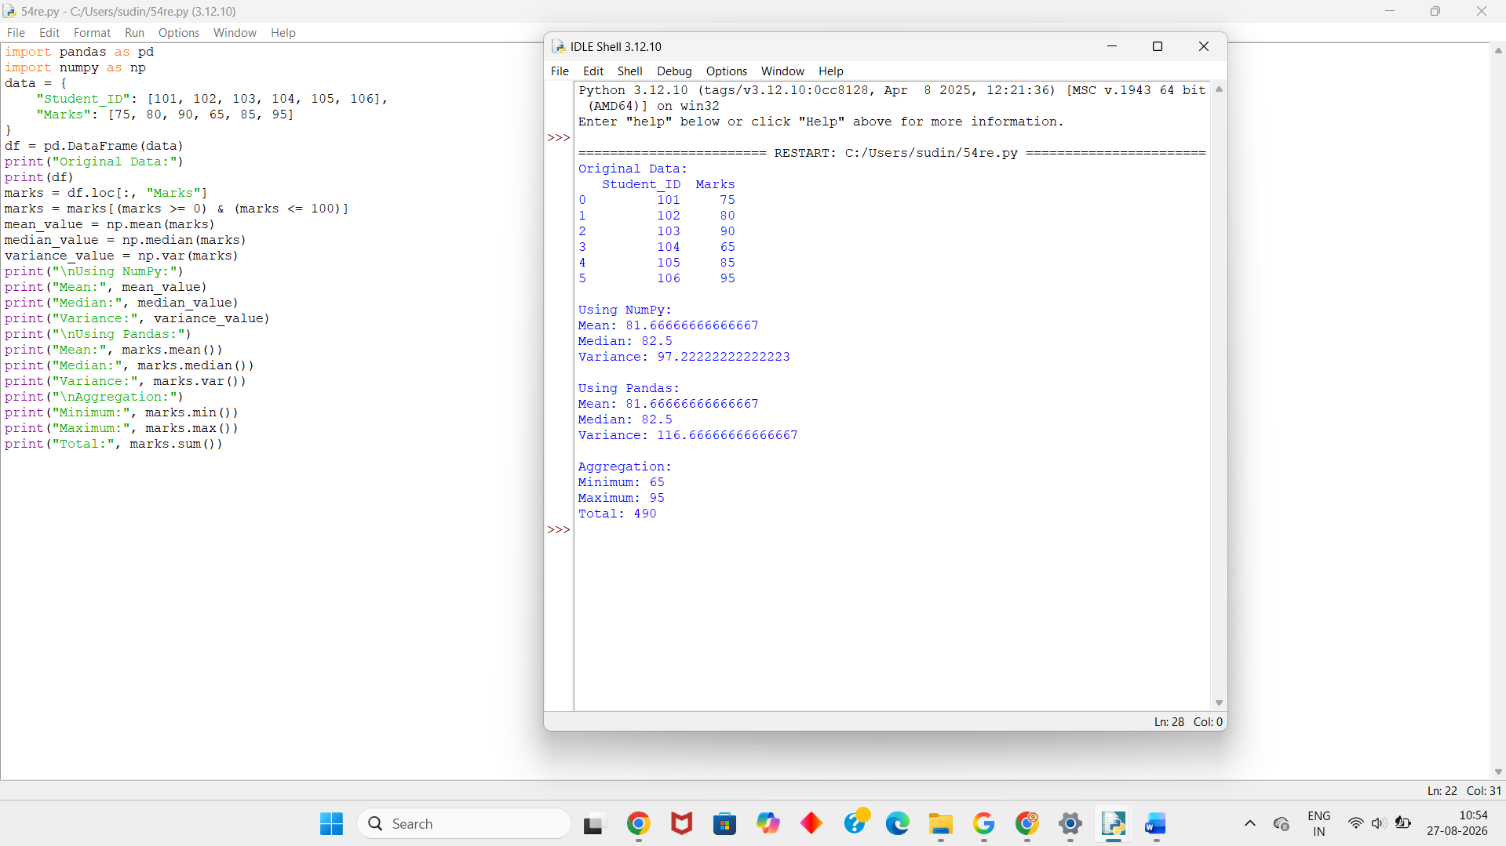
These commands help identify:
- Incorrect data types
- Missing values
- Invalid values
- Unexpected minimum/maximum values
- Incorrect statistical calculations
5. Clarity & Presentation:
Operation | Purpose
loc[] | Select required data
Filtering | Remove invalid values
np.mean() | Calculate NumPy mean
np.median() | Calculate NumPy median
np.var() | Calculate NumPy variance
mean() | Calculate Pandas mean
median() | Calculate Pandas median
var() | Calculate Pandas variance
sum() | Calculate total
min() / max() | Find range
Conclusion:
Thus, NumPy and Pandas can efficiently calculate mean, median, and variance. Filtering removes irrelevant or invalid values, indexing selects the required data, and aggregation functions summarize the dataset. Debugging functions such as describe(), dtypes, and isnull() help verify the accuracy of the results.

5.Design a complete data analysis pipeline that reads multiple data files, processes them using Pandas DataFrames, and generates visualizations. Constraints include: (i) efficient file I/O operations, (ii) correct grouping and sorting of data, (iii) filtering based on user-defined conditions, and (iv) meaningful plotting outputs. Explain how each stage (loading, processing, aggregation, and plotting) will be implemented and optimized, along with debugging steps for handling corrupted files or inconsistent data formats.

Ans: 1. Conceptual Understanding:
A data analysis pipeline is a sequence of steps used to collect, clean, process, analyze, and visualize data.
The main stages are:
- Loading – Read data from files using Pandas.
- Processing – Clean and organize the data.
- Filtering – Select records based on conditions.
- Grouping and Aggregation – Summarize the data.
- Sorting – Arrange data in the required order.
- Plotting – Represent the results visually.
Pandas is mainly used for data processing, while Matplotlib can be used for visualization.
2. Accuracy of Answer:
Pandas DataFrame can be used to store and process the data.
For file input:
df = pd.read_csv("sales.csv")
For filtering:
filtered = df[df["Sales"] > 500]
For grouping:
result = df.groupby("Category")["Sales"].sum()
For sorting:
result = result.sort_values(ascending=False)
For visualization:
result.plot(kind="bar")
These operations provide an efficient way to analyze the dataset.
3. Application of Knowledge:
Step 1 – Loading Data
Multiple datasets can be loaded using Pandas.
df1 = pd.read_csv("sales1.csv")
df2 = pd.read_csv("sales2.csv")
They can be combined using:
df = pd.concat([df1, df2], ignore_index=True)
Step 2 – Filtering
For example, sales greater than ₹500 can be selected:
filtered = df[df["Sales"] > 500]
Step 3 – Grouping
Sales can be grouped according to category:
grouped = filtered.groupby("Category")["Sales"].sum()
Step 4 – Sorting
grouped = grouped.sort_values(ascending=False)
Step 5 – Plotting
grouped.plot(kind="bar")
This gives a meaningful visualization of sales by category.
4.Completeness of Response:
Full Python Code:
import pandas as pd
import matplotlib.pyplot as plt
data1 = {
"Product": ["Laptop", "Phone", "Tablet", "Laptop"],
"Category": ["Electronics", "Electronics", "Electronics", "Electronics"],
"Sales": [800, 600, 400, 900]
}
data2 = {
"Product": ["TV", "Phone", "Tablet", "TV"],
"Category": ["Electronics", "Electronics", "Electronics", "Electronics"],
"Sales": [700, 550, 450, 1000]
}
df1 = pd.DataFrame(data1)
df2 = pd.DataFrame(data2)
df = pd.concat([df1, df2], ignore_index=True)
print("Combined Data:")
print(df)
filtered = df[df["Sales"] > 500]
print("\nFiltered Data:")
print(filtered)
grouped = filtered.groupby("Product")["Sales"].sum()
grouped = grouped.sort_values(ascending=False)
print("\nSales by Product:")
print(grouped)
grouped.plot(kind="bar")
plt.title("Sales by Product")
plt.xlabel("Product")
plt.ylabel("Total Sales")
plt.xticks(rotation=0)
plt.show()
Output:
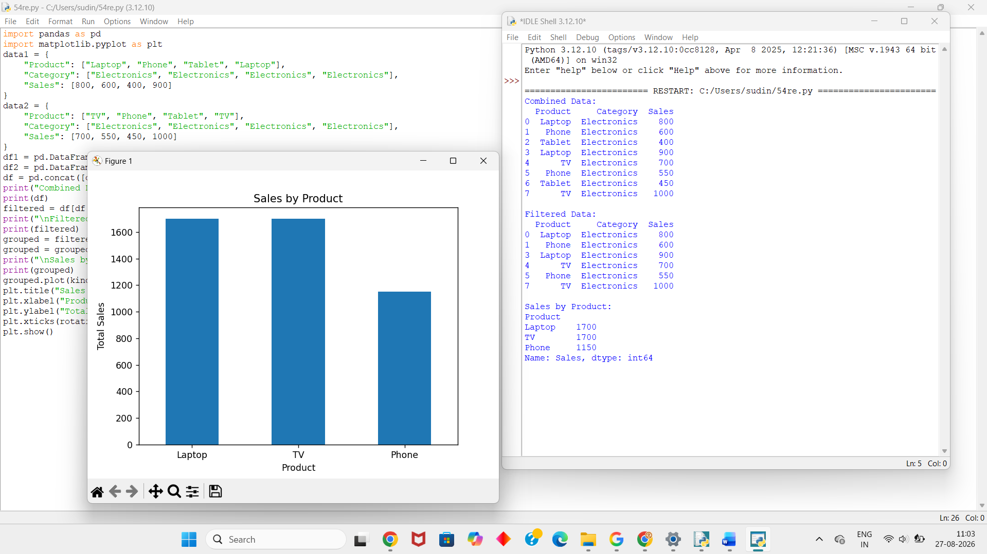
Loading/Creation: Creates two DataFrames representing different data files.
Combining: pd.concat() combines the datasets.
Filtering: Only sales greater than 500 are selected.
Grouping: groupby() calculates total sales for each product.
Sorting: Products are arranged from highest to lowest sales.
Plotting: A bar chart shows total sales for each product.
Debugging:
If errors occur while reading or processing files, the following checks can be used:
print(df.head())
print(df.shape)
print(df.dtypes)
print(df.isnull().sum())
To check column names:
print(df.columns)
To check whether the required column exists:
print("Sales" in df.columns)
If a file is corrupted or has an inconsistent format, it should be checked before combining it with other files.
5. Clarity & Presentation:
Operation | Purpose
pd.read_csv() | Read CSV files
pd.DataFrame() | Create DataFrame
pd.concat() | Combine multiple datasets
Filtering | Select required records
groupby() | Group data
sum() | Aggregate sales
sort_values() | Sort results
plot() | Generate visualization
head() | Inspect data
dtypes | Check data types
isnull() | Check missing values
Conclusion:
Thus, a complete Pandas-based data analysis pipeline can load multiple datasets, combine them, filter required records, group and aggregate the data, sort the results, and generate meaningful visualizations. Debugging functions such as head(), dtypes(), shape, and isnull() help identify corrupted or inconsistent data and ensure accurate analysis.
15. You are required to integrate and analyze data from multiple IoT devices with varying sampling rates and missing timestamps. Constraints include: (i) aligning time-series data correctly, (ii) handling missing intervals without distortion, and (iii) maintaining computational efficiency. Explain how you will use Pandas time-series functions, reindexing, interpolation, and aggregation to enforce these constraints, and discuss debugging techniques for misaligned or inconsistent time-series data.
Ans: 1. Conceptual Understanding:
IoT devices generate data at different time intervals. For example, one device may record temperature every minute, while another device records humidity every two minutes.
Pandas time-series functions can be used to:
- Convert timestamps into datetime format.
- Align data according to time.
- Identify missing timestamps.
- Fill missing values using interpolation.
- Aggregate data over fixed time intervals.
The main constraints are:
- Correctly align timestamps.
- Handle missing time intervals.
- Avoid unnecessary computation and memory usage.
2. Accuracy of Answer:
The following Pandas functions are useful:
- pd.to_datetime() → converts timestamps into datetime format.
- set_index() → creates a time-based index.
- resample() → changes data to a common time frequency.
- reindex() → identifies missing timestamps.
- interpolate() → estimates missing values.
- mean() → aggregates values.
- sort_index() → maintains chronological order.
For example:
df["Timestamp"] = pd.to_datetime(df["Timestamp"])
df = df.set_index("Timestamp")
Missing values can be handled using:
df["Temperature"] = df["Temperature"].interpolate()
3. Application of Knowledge:
Step 1 – Convert Timestamp
df["Timestamp"] = pd.to_datetime(df["Timestamp"])
This ensures that timestamps are correctly recognized by Pandas.
Step 2 – Set Timestamp as Index
df = df.set_index("Timestamp")
This allows Pandas time-series operations to be performed efficiently.
Step 3 – Sort the Data
df = df.sort_index()
This ensures that the records are in chronological order.
Step 4 – Align Time Intervals
The data can be converted to a common frequency using resample():
df = df.resample("1min").mean()
This creates one-minute intervals.
Step 5 – Handle Missing Values
Missing intervals can be filled using interpolation:
df["Temperature"] = df["Temperature"].interpolate()
Interpolation estimates values between available observations without simply copying the same value.
4. Completeness of Response:
Full Python Code:
import pandas as pd
import numpy as np
data = {
"Timestamp": [
"2026-08-27 10:00",
"2026-08-27 10:01",
"2026-08-27 10:03",
"2026-08-27 10:05",
"2026-08-27 10:06"
],
"Temperature": [30.1, 30.3, 30.7, 31.0, 31.2],
"Humidity": [65, 66, 68, 70, 71]
}
df = pd.DataFrame(data)
print("Original Data:")
print(df)
df["Timestamp"] = pd.to_datetime(df["Timestamp"])
df = df.set_index("Timestamp")
df = df.sort_index()
print("\nTime-Series Data:")
print(df)
df = df.resample("1min").mean()
print("\nAfter Resampling:")
print(df)
df["Temperature"] = df["Temperature"].interpolate()
df["Humidity"] = df["Humidity"].interpolate()
print("\nAfter Interpolation:")
print(df)
print("\nAverage Temperature:", df["Temperature"].mean())
print("Average Humidity:", df["Humidity"].mean())
print("\nMissing Values:")
print(df.isnull().sum())
Output:
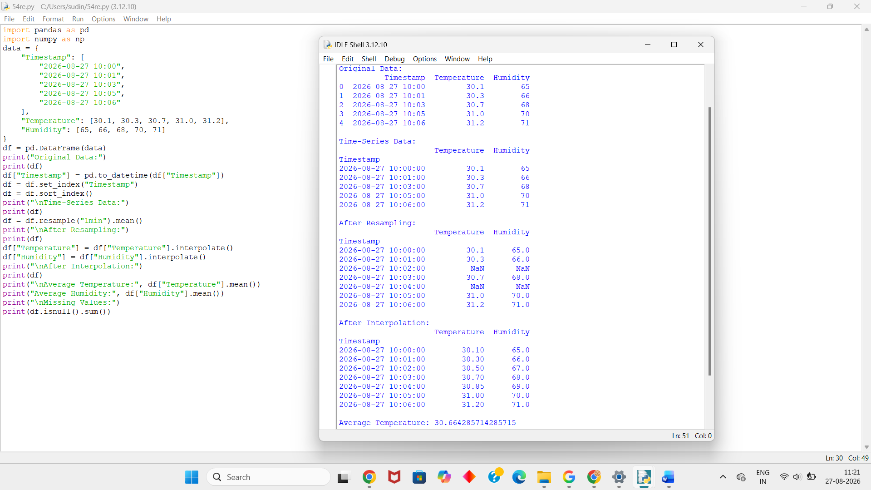
Debugging:
The following commands can be used to identify problems:
Check data types:
print(df.dtypes)
Check missing values:
print(df.isnull().sum())
Check timestamp order:
print(df.index.is_monotonic_increasing)
Check duplicate timestamps:
print(df.index.duplicated().sum())
Check the time range:
print(df.index.min())
print(df.index.max())
These checks help identify incorrect timestamps, duplicate records, missing values, and misaligned time-series data.

5. Clarity & Presentation:
Pandas Operation | Purpose
pd.to_datetime() | Converts timestamps
set_index() | Creates time-based index
sort_index() | Sorts timestamps
resample() | Aligns different sampling rates
interpolate() | Handles missing values
mean() | Performs aggregation
isnull() | Checks missing values
index.duplicated() | Detects duplicate timestamps
Conclusion:
Thus, Pandas time-series functions can effectively integrate IoT data with different sampling rates. By converting timestamps, setting a time index, resampling to a common frequency, reindexing or creating missing intervals, and using interpolation, the data can be aligned without unnecessary distortion. Sorting, aggregation, and debugging functions help maintain accuracy, consistency, and computational efficiency.

RUBRICS FOR CALCULATION

Criteria | Weightage | Level 4 – Exemplary (5 Marks) | Level 3 – Proficient (4 Marks) | Level 2 – Developing (2–3 Marks) | Level 1 – Beginning (0–1 Mark)
Conceptual Understanding | 30 | Demonstrates clear and complete understanding of the concept | Good understanding with minor gaps | Basic understanding with some misconceptions | Poor or incorrect understanding
Accuracy of Answer | 25 | Completely correct answer with no errors | Mostly correct with minor errors | Partially correct with noticeable errors | Incorrect or irrelevant answer
Application of Knowledge | 15 | Correctly applies concepts to solve the question/problem | Applies concepts with minor mistakes | Limited or partially correct application | No or incorrect application
Completeness of Response | 15 | Covers all required parts of the question | Covers most parts with minor omissions | Covers only some parts | Incomplete or missing response
Clarity & Presentation | 15 | Clear, concise, and well-organized answer | Understandable with minor issues | Somewhat unclear or poorly structured | Difficult to understand

